Web Services: recent accomplishments and impact
A summary of program leadership, operational improvements, and hands-on delivery across the web ecosystem at IGT.
Prepared October 2026
$150K+  Cost reduction  Web services team |  | 700+  Web requests completed  Personally delivered |  | ~230  Requests per year  Sustained annual pace |  | 3 yrs  Tenure at IGT  Leading web services

Cost management and operational efficiency
Savings, platform governance, and repeatable intake processes
Reduced Web Services team costs by more than $150K. Identified and eliminated redundant tooling, vendor spend, and process inefficiencies across the web services function, delivering savings that can be redirected toward higher-value initiatives.
Operationalized the Bynder digital asset management platform. Resolved structural issues in asset taxonomy and permission sets, transforming Bynder from a partially adopted tool into a governed, reliable system of record for brand and marketing assets.
Established workstreams and intake flows for marketing teams. Designed and implemented processes that allow marketing stakeholders to submit, track, and manage web-related requests, improving visibility, reducing ad-hoc asks, and creating a predictable pipeline for the web team.
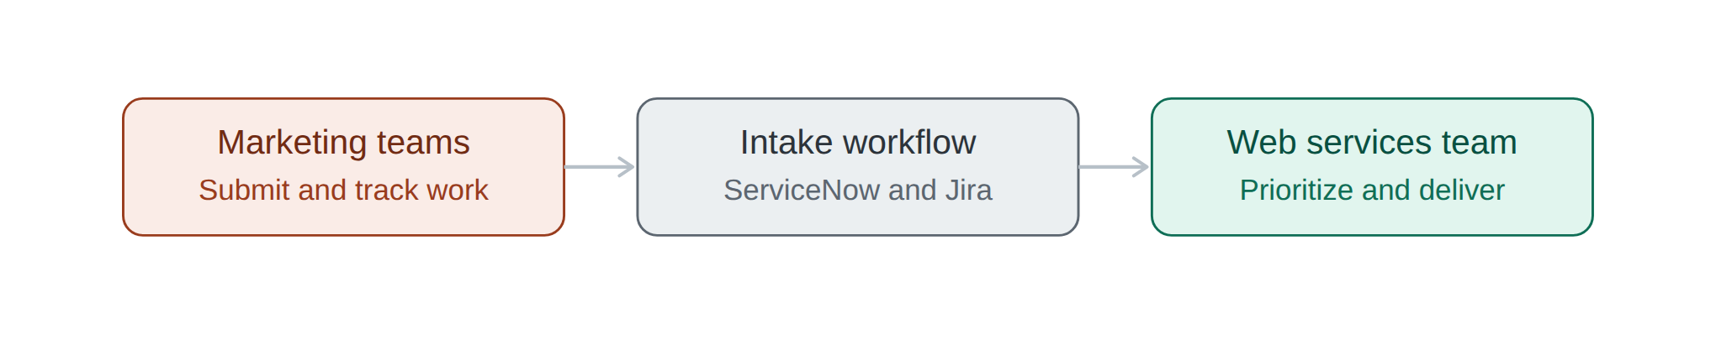
Marketing request intake: requesters submit and track their own work, and the web team receives a prioritized queue.

Program and project leadership
Enterprise rebrand and the end-to-end web rebuild
Led and deployed an enterprise-level rebrand across the web ecosystem. Owned end-to-end execution of the rebrand across all web properties, coordinating design, content, development, and QA to deliver a consistent brand experience on schedule.
Leading the end-to-end web rebuild program. Serving as the primary owner for the rebuild, partnering with internal IGT teams and vendor BlueModus to deliver UX design, API development, content strategy, and web data architecture. Responsible for scope, prioritization, vendor accountability, and alignment with business objectives.
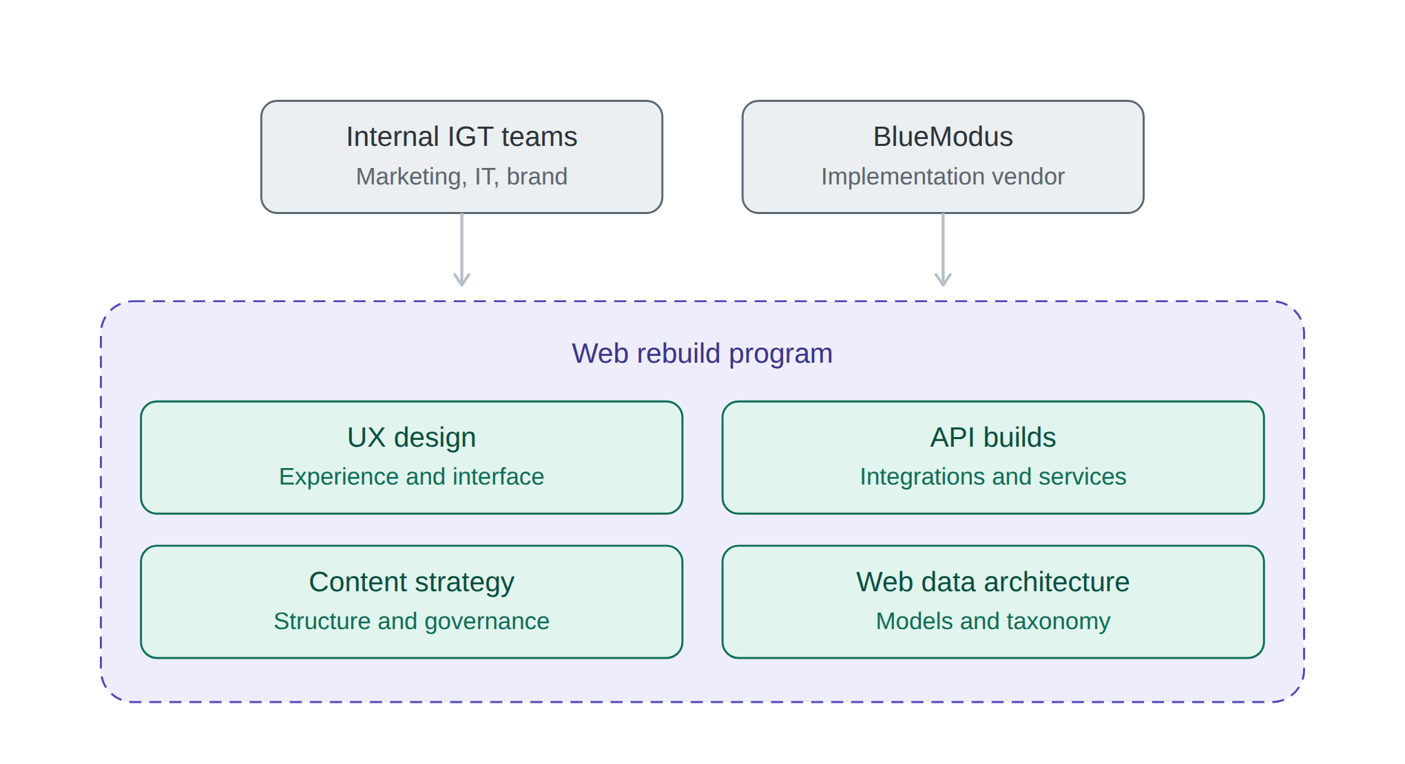
Web rebuild program: internal teams and the vendor feed four coordinated workstreams under single ownership.

Strategy and executive engagement
Digital ecosystem direction and leadership reporting
Orchestrating digital ecosystem strategy for web and omnichannel. Defining how web channels fit within the broader omnichannel experience, ensuring platform, content, and data decisions support long-term digital goals rather than isolated projects.
Delivering regular reporting to the CIO, SVPs, Senior Directors, and the broader SLT. Providing consistent updates on program status, risks, costs, and outcomes, enabling informed executive decision-making and maintaining leadership confidence in the web portfolio.

Team leadership and delivery
Leading the team while staying hands-on
Personally completed more than 700 web requests over a three-year tenure at IGT. Averaging roughly 230 requests a year, this reflects a sustained, hands-on delivery record maintained alongside program and team leadership responsibilities, demonstrating both individual throughput and the ability to scale beyond it.
Sustained effective leadership of the Web Services team. Supported team members in executing their responsibilities, removed blockers, and maintained delivery quality through a period of significant change across the rebrand, rebuild, and new tooling.
Proactively resolved team and cross-functional issues. Addressed pipeline bottlenecks and communication gaps as they emerged, keeping work moving and preserving healthy working relationships across teams and vendors.

Technical breadth
Platforms used to deliver this work
Leveraged a diverse technology stack to execute responsibilities. Bridged business, creative, and technical domains across service management, digital asset management, content management, project tracking, creative tooling, AI assistance, and cloud infrastructure.
Working familiarity with adjacent enterprise systems. Regularly collaborated with the teams that own Azure DevOps and Blob Storage, SQL Server, SAP, Matrix, and Airtable. Exposure here is adjacent rather than hands-on: enough to coordinate dependencies, understand how data moves between these systems and the web ecosystem, and partner effectively with their owners, without claiming depth in the platforms themselves.
Primary platforms: ServiceNow, Bynder, Kentico, Jira, Adobe Creative Cloud, Claude, AWS
Adjacent systems, working familiarity: Azure DevOps, Azure Blob Storage, SQL Server, SAP, Matrix, Airtable

